Mantid
PM report to Project Management Board
19th July 2017
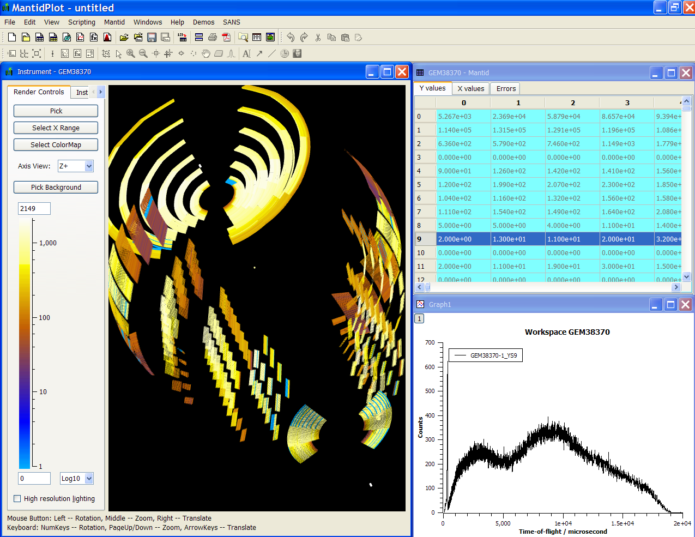
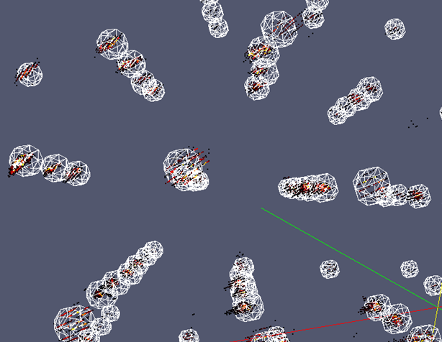
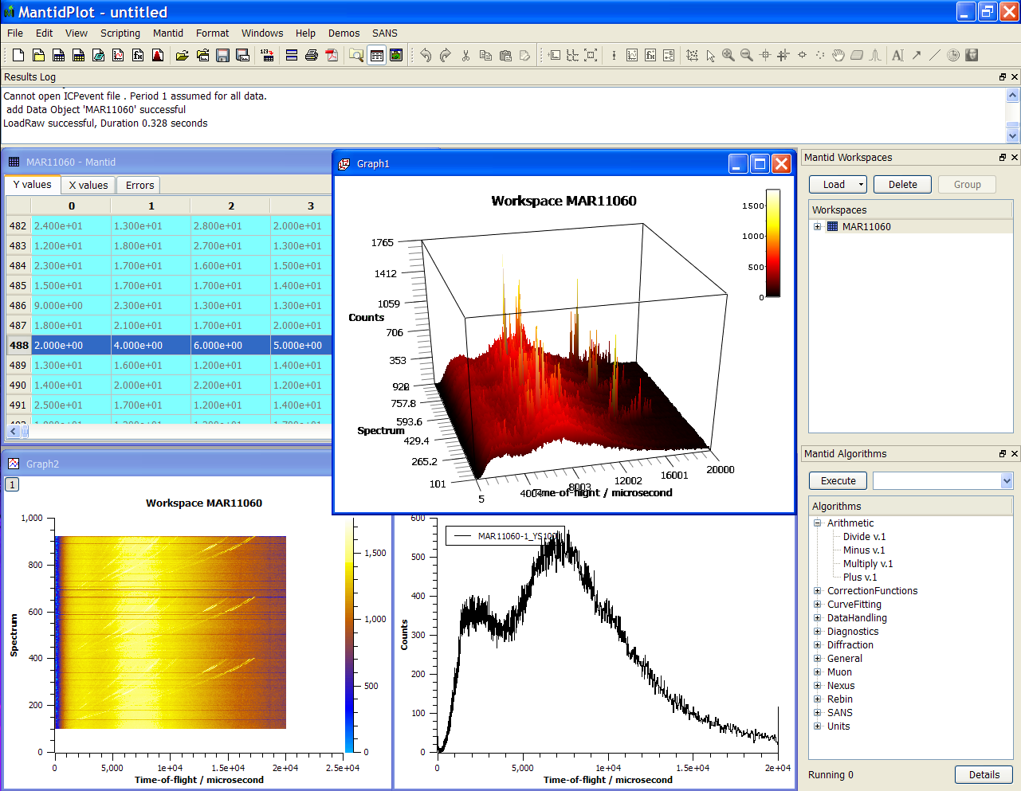
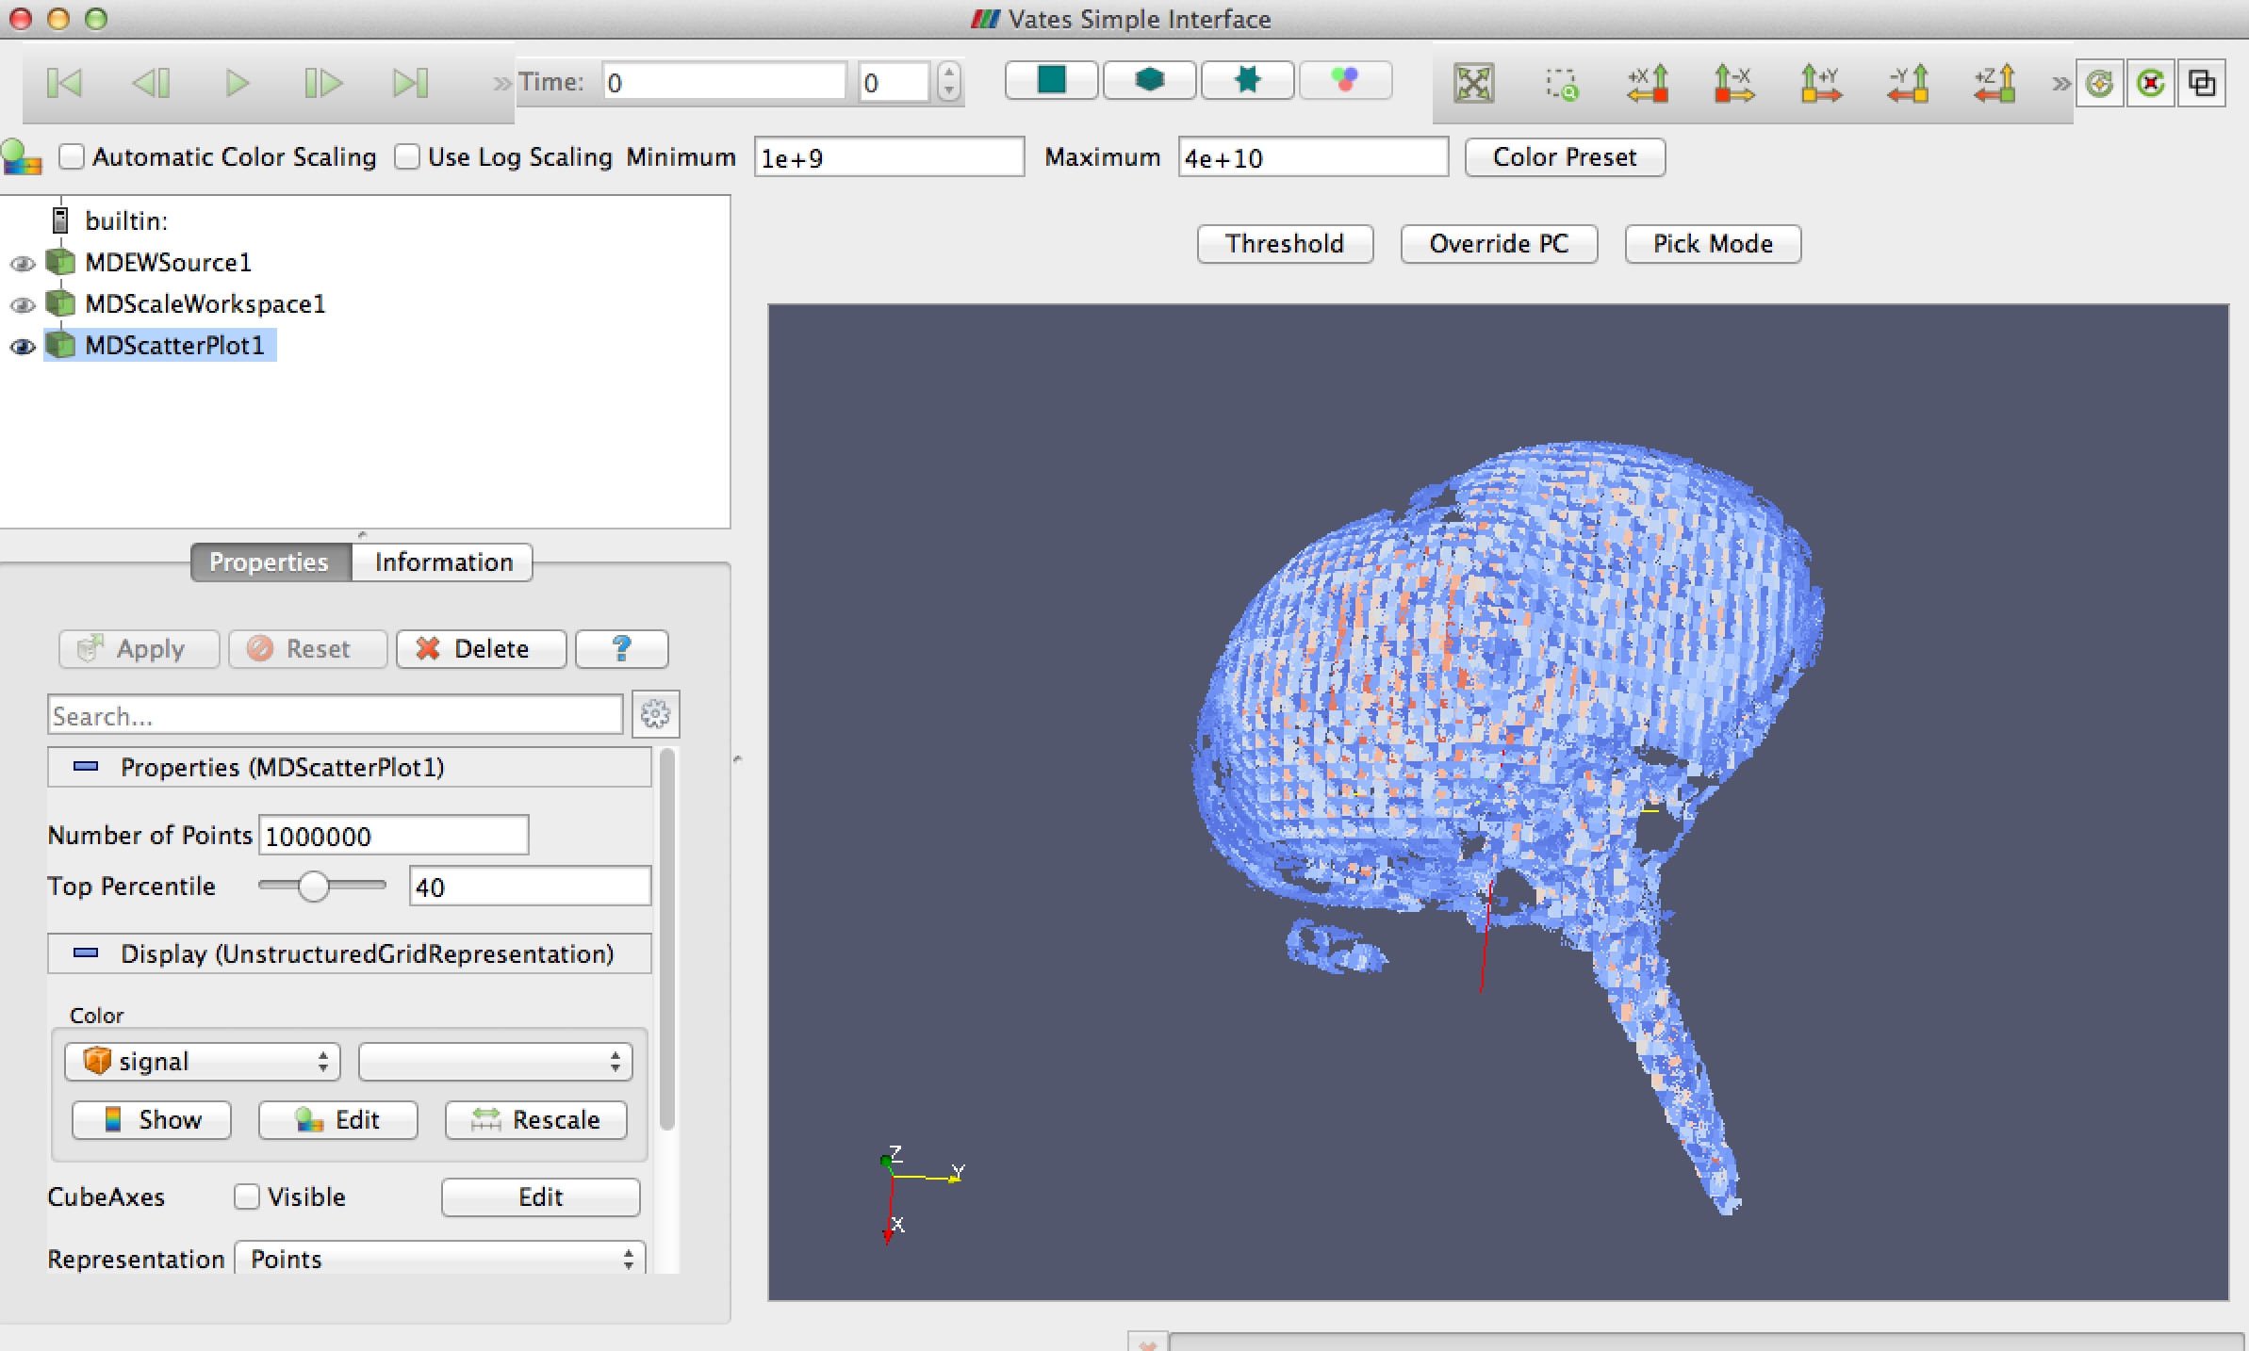
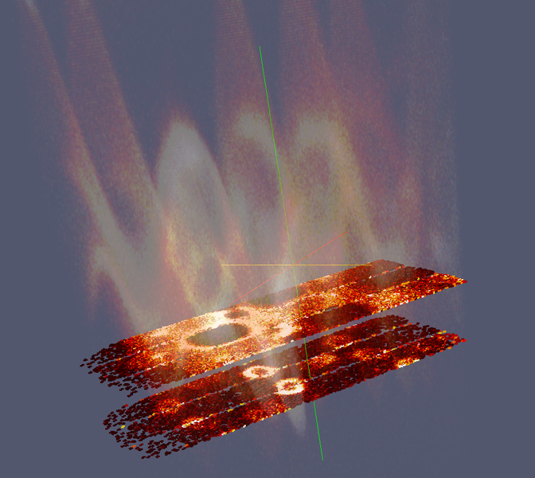
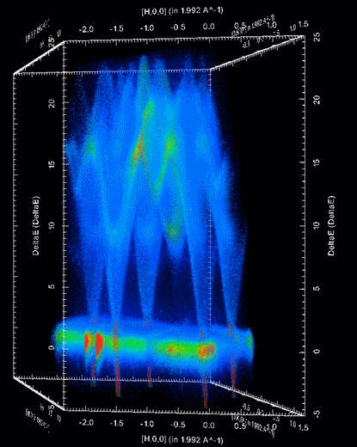

Document Control
This document is under document control. All members of the distribution list will receive updated copies whenever alterations are made. All other copies are uncontrolled.

Contributors
Name | Role | Company
Nicholas Draper | Author | Tessella

Document Approval
Name | Role | Company

Distribution
Name | Role | Company
Project Management Board Members | Recipient | STFC & ORNL
Mantid Project Repository | Filing | STFC & ORNL

Revision History
Author | Issue | Date | Description
Nicholas Draper | V1.R1.M0 | 17-July-2017 | 1st version written

References
Document | Ref | Date | Details and Version
Project Specification | [PS] |  | https://github.com/mantidproject/documents/blob/master/Project%20Management/ProjectSpecification.doc?raw=true
Stakeholder Plan | [SP] |  | https://github.com/mantidproject/documents/blob/master/Project%20Management/StakeholderPlan.doc?raw=true
Risk Register | [RR] |  | https://github.com/mantidproject/documents/blob/master/Project%20Management/RiskRegister.xls

Table of Contents
1 Introduction 3
2 Project Documentation 4
3 Project Status 4
4 Usage of Mantid in various Environments 5
5 Future Release Dates 6
6 Users Workshop 7
7 Progress on Mantid 4.0 10
8 Appendix A: Metrics 11

Introduction

Purpose of this Document
This report details the current state of the Mantid project. The project management board will use this report as an item for discussion at the meeting.

Scope of this Document
The scope of this document is limited to the Mantid project, both for progress up to the meeting of the Project management board, and plans for the future.

Project Documentation
The project documentation is available through the links below. The documents have not been changed since the last PMB meeting.

Stakeholder Plan:
https://github.com/mantidproject/documents/blob/master/Project%20Management/Stakeholder Map.doc?raw=true
No changes this time

Risk Register:
https://github.com/mantidproject/documents/raw/master/Project-Management/RiskRegister.xls
No changes this time.

Project Status

Development Progress
Since the last PM report we have released the following new versions of Mantid:

- Release 3.9 – 14th February 2017
  - Patch Release 3.9.1 – 1st March 2017
  - Patch Release 3.9.2 – 28th March 2017
- Release 3.10 – 9th June 2017

The releases were made on time according to plan.

The project metrics in Appendix A.

Usage of Mantid in various Environments
We currently fully support the following environments:
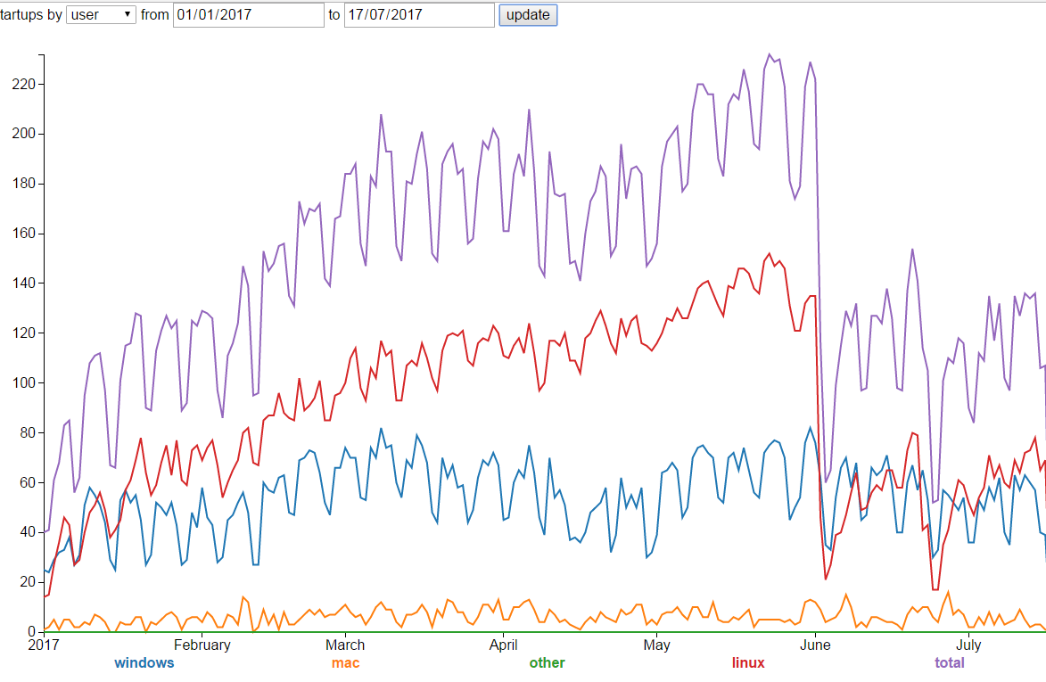
- RHEL 7 64bit
- Windows 7+ 64 bit
Total
Linux
Windows
Mac
- Ubuntu 14.04 64 bit
- Ubuntu 16.04 64 bit
- OS X 10.10+
Limited Support:
Fedora 20

Current Usage:

http://reports.mantidproject.org/
Looking since the last PMB we have a continued growth of users running Mantid, currently peaking at 220 unique users per day. There is an obvious 50% reduction in users when the SNS cycle ended in June and the start of July. It is also worth noting that this shows that the in cycle usage of Mantid is almost universally Linux based.
These numbers are not affected by the development team or the build and test servers.

Operating System Usage:
Usage since last PMB (2 months 1 week):
This shows the total distinct users from the start of 2017 until the 17th of July. So while the previous graph shoed the usage per day, this shows the total number of unique users by OS over the year so far.
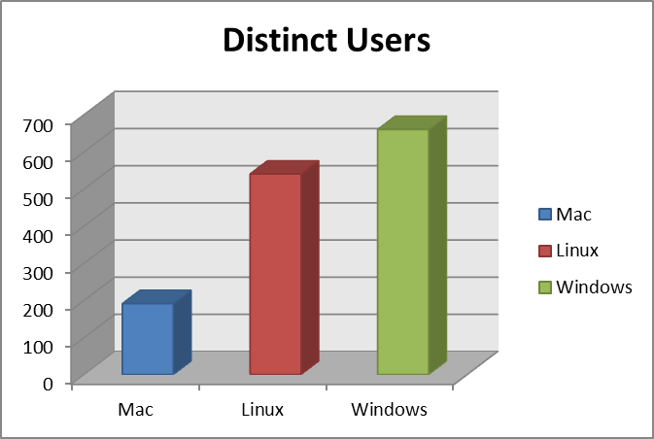

Total Users
This graph shows the total number of unique users per year of Mantid, the normalized values correct for the current years counts being only part way through the year.
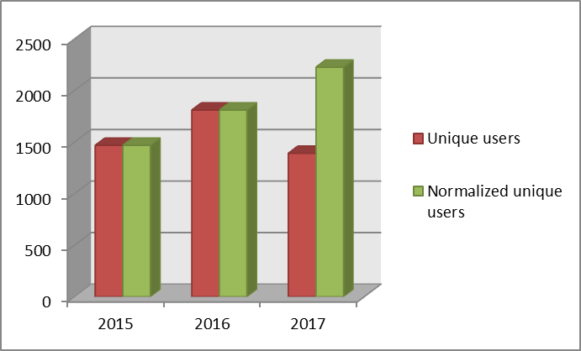

Future Release Dates
The proposed release dates for the future are:
- v3.11 9th October 2017
- v3.12 (?4.0) 5th February 2018
This does not include patch releases.

Users Workshop

Mantid 4.0
The users workshop in June this year was a great opportunity to introduce the plans for Mantid 4.0, and more importantly to judge the reactions to the potentially more disruptive changes contained within the plans.
It was always part of the plan to use this user forum to steer the future direction of the work we focus on for Mantid 4.0.

Plans presented
The plans presented are linked here:
- Mantid 4.0 and other areas for discussion (Nick Draper)
- Mantidplot TNG (Martyn Gigg)
- Algorithm Renaming (Andrei Savici)
- Property Renaming (Andrei Savici)

In terms of areas for discussion they broke down into 3 areas:
- Building a new Mantid Workbench
- Algorithm and Property renaming
- Python API changes

Feedback

Building a new Mantid Workbench
This was presented as the PMB approved approach for tackling a number of dependencies that Mantidplot uses that have become deprecated (particularly the versions of QWT and Qt we use).
Positive Reactions | Negative Reactions
The general consensus was that you need to do this, so go ahead. | Users (or a sub group) want to be involved at an early stage and during development to help direct the user interaction.
Better graphing and better control of graphing was well accepted | The Keep / Make Current approach for graphing received mixed feedback, many were confused by the terminology.
The “Lite” mode of the new Mantid workbench appealed to the Muon, SANS and reflectometry groups | There was some concern about whether our estimates will prove to be correct.
Better testing of the UI layer, leading to more robustness was popular.

Algorithm and Property renaming
The proposal for renaming algorithms to a common approach as part of a move to Mantid as a SciPy styled library was discussed. Associated with this breaking change several improvements to property renaming were discussed as well.

This proved to be an area that prompted a lot of discussion, and several instrument scientists made the point of speaking to the development team after the general debate as well.
Positive Reactions | Negative Reactions
The approach of structuring the python API into more sensible packages was appreciated be those who are more included to programming. | The level of breaking change of renaming algorithms and properties was a serious concern to many of the attendees.
The general objective of making algorithms easier to find was approved of. | Attendees wanted to see how this renaming fitted into the plan of restructuring Mantid as a SciPy styled library, and quite what we meant by that objective.
 | Property changes raised the same level of concern due to the breaking nature of the changes.

Python API changes
The python API changes fell into two categories, those that added new and existing functionality to the python API, and those that took away deprecated methods. Only removing deprecated methods is a breaking change for existing scripts.
Positive Reactions | Negative Reactions
Several people wanted to see a more complete overview of the Python API, particularly how to access all of the information within a workspace. | There was little desire to update scripts to accommodate breaking changes, although this might change if they could be justified as part of an accepted holistic view of the Python API.
More training offered in this area would appeal to the more involved users. | There was some confusion about how easy it is to get data in and out of Mantid via Python. Several users did not appear to know of the methods that are already available.

Proposed Changes to Mantid 4.0
It was always part of the plan that we needed to listen to the feedback from our users and adapt the plan accordingly, that is why the requirements gathering section of the plan was aligned with the Users Workshop.

Building a new Mantid Workbench
The new Mantid workbench was well received, we will continue with this aspect of Mantid 4.0 as planned, with the addition of a number of points where we will demo the new Workbench, provide prototypes and gather feedback from a shortlist of interested instrument scientists. This had been implicitly assumed, but was not explicitly presented or detailed on the project plan, this will be updated to make this explicit.

The new workbench will be provided to install side by side with Mantidplot, and the withdrawal of Mantidplot will be planned separately once all techniques can be acceptably supported in the new workbench.

Algorithm and Property renaming
The breaking nature of these changes was clearly unpopular and not sufficiently justified by the improvements to the naming scheme.

The improvements to the Python API package structure however are desirable as part of a move towards Mantid as a SciPy styled package. It is clear that we need to agree on what we all mean to implement as part of that strategic objective. To move us along here I have submitted a design document to the TSC to agree these terms and propose a set of changes that may fulfil the objective without introducing and breaking changes to users scripts. It does not provide as consistent a final outcome for algorithm naming, but retains some of the more important strategic changes without affecting existing scripts.
https://github.com/mantidproject/documents/blob/Mantid_As_a-_SciPy_Styled_Package/Design/Mantid_As_a%20_SciPy_Styled_Package.md
If approved this would not introduce any breaking changes and would not therefore need to be time aligned with the Mantid 4.0 release.

There are a few changes associated with the IndexProperty changes that are vital to the MPI processing plans for the ESS, and these affect some of the most used algorithms within Mantid. These were breaking changes in the initial plan, but we now plan to hide those changes within the autogenerated python API for algorithms to make these changes compatible with existing scripts.

Python API changes
Elliot Oram who is re-joining us in September will gather the Python API tutorial together alongside gathering requirements for Total Scattering in Mantid. This will give provide the Holistic view of the API as well as a few worked examples aimed at documenting and improving the ability to get data into and out of Mantid easily. In addition we plan to refresh / extend the final Mantid training course “Extending Mantid Using Python” with this material.

Exposing the methods and objects for HistogramData and Instrument 2.0 can be done without introducing any breaking changes. Therefore it makes most sense to implement these when they are ready, rather than aligning these changes with Mantid 4.0 artificially.

The removal of methods for accessing Histogram data the old way (a large breaking change) or accessing Instrument 1.0 (a smaller breaking change) can be considered once the usage of the new API methods has been thoroughly adopted. For now the old methods can be made to access the new objects and continue to work, they might just be slower than they could be.

Other Requirements
The requirements from the other areas have been adopted by the ISIS sub team leaders that cover those areas, they are separating out the facility specific requirements from those that are generic. Facility specific issues will be handed over to the development leads in that facility, and joint requirements will be handled in collaboration. For ISIS these requirements will be added to the annual objective spreadsheet according to the need and resource availability.

Progress on Mantid 4.0
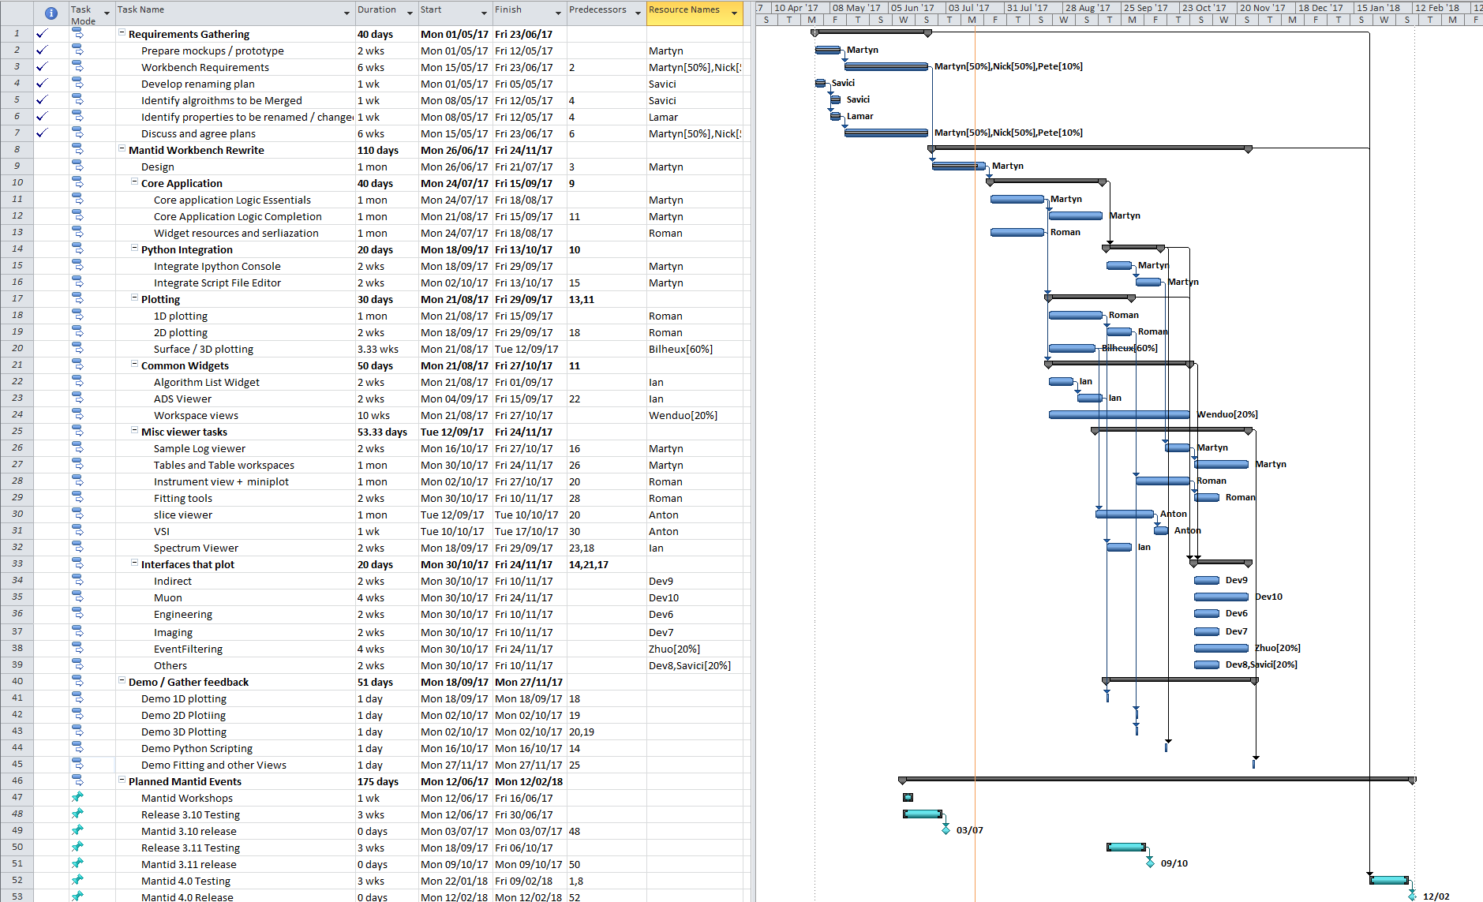
This gannt chart has been updated given that the changes in 6.1.3 and updated with progress to date.

Appendix A: Metrics

Project Metrics
The code metrics are independently generated and displayed here
http://www.openhub.net/p/Mantid/analyses/latest/languages_summary

Total Lines : | 2,154,33 |  | Code Lines : | 1,545,182 |  | Percent Code Lines : | 71.7%
Number of Languages : | 16 |  | Total Comment Lines : | 334,201 |  | Percent Comment Lines : | 15.5%
 |  |  | Total Blank Lines : | 274,956 |  | Percent Blank Lines : | 12.8%

Code, Comments and Blank Lines
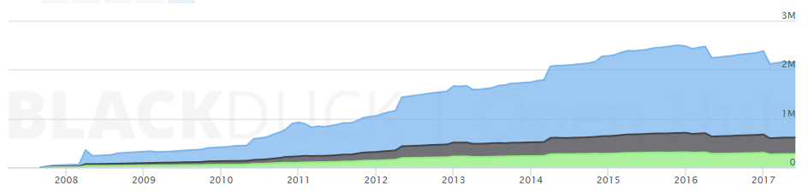
Code
Comments
Blanks

In a Nutshell, Mantid...
- has had 75,839 commits made by 111 contributors
representing 1,545,182 lines of code
- is mostly written in C++
with an average number of source code comments
- has a well established, mature codebase
maintained by a very large development team
with stable Y-O-Y commits
- took an estimated 440 years of effort (COCOMO model)
starting with its first commit in April, 2007
ending with its most recent commit 21 days ago

